**CELL MAKING REPORT**

**INTRODUCTION:**

This report aims to highlight the importance of Electric Vehicles (EVs) in India and the need for manufacturing cells that can be applied in EVs. Currently, there are no cell manufacturers in India, which presents an opportunity for us to take the lead in this growing industry. Considering the increasing demand for EVs in the future, it is crucial to invest in cell manufacturing to meet the rising needs of the market.

We are focused on changing the chemistry of existing cells to achieve rapid charging and long-lasting capabilities. This innovation is key in making EVs more efficient and appealing to consumers. By developing cells that can charge quickly and have a longer lifespan, we can contribute to the growth of the EV sector and reduce our reliance on traditional fuel sources.

The importance of EVs cannot be understated in the current global scenario where sustainability and environmental concerns are at the forefront. By transitioning to electric vehicles, we can significantly reduce carbon emissions and combat climate change. This shift towards cleaner transportation options is essential for a greener and more sustainable future.

In conclusion, the manufacturing of cells for EVs in India holds immense potential and opportunities for growth. By focusing on improving the technology and chemistry of cells, we can contribute to the advancement of the EV industry and move towards a cleaner and more sustainable transportation system for the benefit of all.

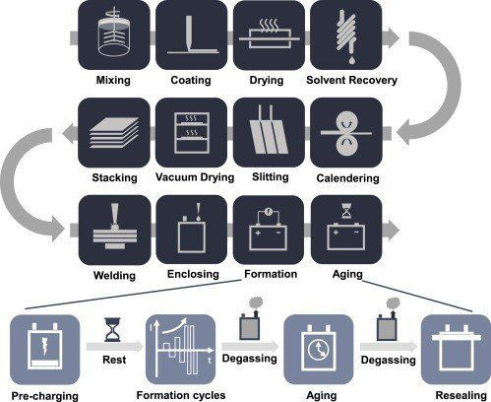

**Importance of EVs in India:**

The importance of EVs in India cannot be overstated. With the increasing concern for environmental sustainability and the need to reduce emissions, EVs offer a cleaner and more efficient alternative to traditional vehicles. In addition, EVs help reduce dependence on fossil fuels, contributing to energy security and cost savings in the long run.



**CELL MANUFACTURING PROCESS:**

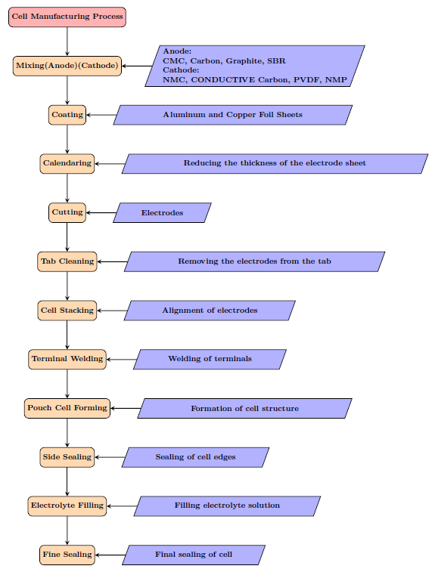

**Mixing:** 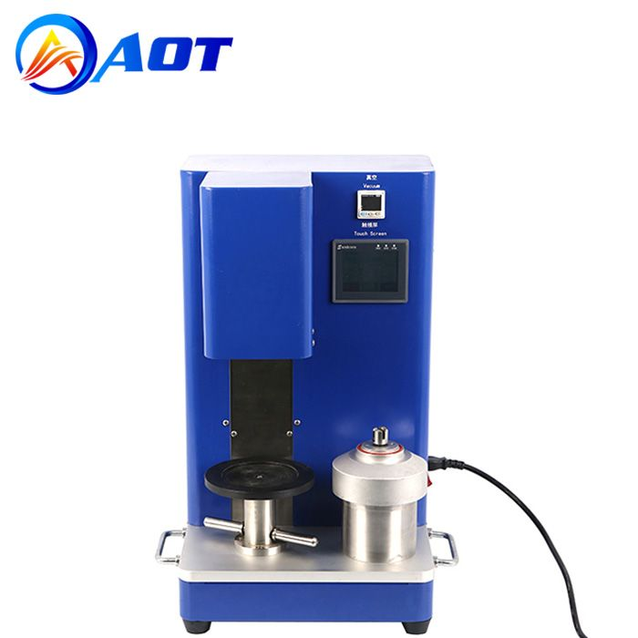

The mixing process in battery manufacturing is a pivotal step for homogeneously blending the active materials, conductive additives, binders, and solvents to form the electrode slurries utilized in lithium-ion battery production. Initially, the individual components are accurately measured and combined in predetermined ratios to achieve the desired electrode composition. The mixture undergoes intensive mixing, typically using high-speed dispersers, planetary mixers, or ball mills, to ensure thorough dispersion and uniform distribution of the materials at the particle level.

This homogenization process is crucial for optimizing the electrochemical performance and consistency of the electrodes, as it influences parameters such as particle size distribution, surface area, and interparticle contacts, ultimately impacting battery capacity, rate capability, and cycling stability. Thus, precise control and optimization of the mixing process are imperative for producing high-quality lithium-ion batteries with reliable performance characteristics.

**Anode Mixing :**

The primary active material for anodes in lithium-ion batteries is graphite. It serves as the host material for lithium ions during charge and discharge cycles. Other advanced materials like silicon or tin-based compounds can also be used to boost battery performance.

Conductive additives, such as carbon black are added to improve the electrical conductivity of the electrode. This helps with electron transfer during battery operation, enhancing overall performance.

Binders carboxymethyl cellulose (CMC) are crucial for attaching the active material and conductive additives to the current collector substrate. They provide mechanical stability and uphold electrode integrity over the battery's lifespan.

Solvents such as water are crucial for forming a slurry mixture with the active material, conductive additives, and binder. The right solvent choice ensures optimal viscosity and rheological properties of the slurry for coating and electrode formation during subsequent processing steps.

Styrene-Butadiene Rubber (SBR) is commonly used as an elastomeric binder in the anode manufacturing process for lithium-ion batteries. It enhances mechanical integrity, improves adhesion between active material particles and the current collector substrate, controls volume expansion/contraction, and contributes to cycling stability and battery lifespan.

Mixing equipment such as planetary mixers or ball mills are essential to ensure a thorough dispersion of materials during the anode mixing process. This helps in achieving uniform distribution and consistency in the anode formulation for effective battery performance.

**Cathode Mixing:**

The primary active materials in cathodes for lithium-ion batteries are lithium metal oxides, like NMC which store and release lithium ions during charging and discharging.

To enhance electrical conductivity, conductive additives like carbon black is used in the cathode mix. This ensures efficient electron transport during battery operation.

Binders such as PVDF play a crucial role in binding the active material and conductive additives together, as well as adhering them to the current collector substrate. This helps improve the mechanical stability of the cathode.

Solvents like NMP is utilized to dissolve the binder and aid in creating a slurry with the active material and conductive additives. The choice of solvent impacts the viscosity and rheological properties of the slurry, which are vital for the coating process.

**Coating:**

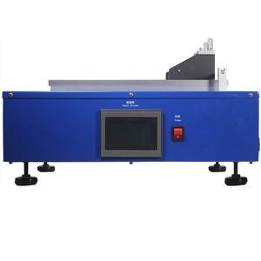

The coating process in battery manufacturing is vital step for producing the electrode layers essential for lithium-ion battery cells. Initially, a slurry mixture containing active materials, conductive additives, binders, and solvents is prepared to form the electrode coating. This slurry is then uniformly applied onto a substrate, typically a metal foil, using a variety of coating techniques such as doctor-blade coating, slot-die coating, or roll-to-roll coating.

Subsequent drying and solvent removal steps ensure the formation of a thin and uniform electrode layer with controlled thickness and composition. The coating process is crucial for determining the quality and performance of the electrode, influencing factors such as the electrode's porosity, surface area, and thickness distribution, which in turn affect the battery's capacity, energy density, and cycling stability.

Thus, precise control and optimization of the coating process are essential for producing high-performance lithium-ion batteries suitable for various applications.

**Calendaring:**



Calendaring process in battery is a critical step for enhancing the performance and structural integrity of electrode materials used in lithium-ion batteries. During calendaring, electrode sheets, typically composed of active materials, conductive additives, and binders, are passed through a series of rollers under controlled pressure and temperature conditions. This process compresses the electrode material, reducing its thickness and increasing its density while simultaneously improving its mechanical strength and uniformity.

Calendaring also helps to align the active material particles within the electrode matrix, enhancing the electrode's electrochemical performance and ensuring consistent battery performance. Additionally, calendaring can modify the porosity and surface morphology of the electrode, optimizing electrolyte infiltration and facilitating efficient ion transport within the battery cell. Overall, the calendaring process plays a crucial role in optimizing the performance, energy density, and cycle life of lithium-ion batteries, making it an essential step in battery manufacturing.

**Electrode Cutting:**

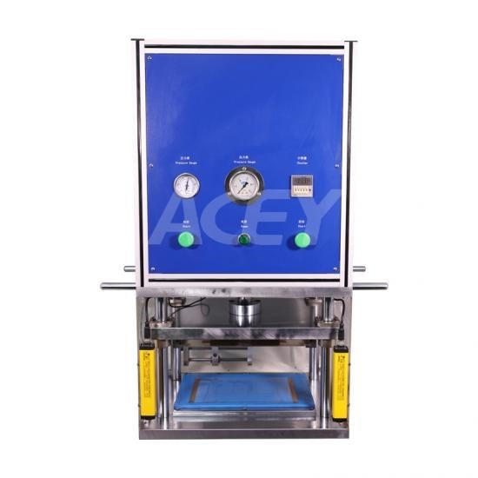

The electrode cutting process in battery manufacturing is a crucial step for creating the electrode sheets that form the core components of lithium-ion battery cells.

Initially, large rolls of electrode material, typically composed of a mixture of active material, conductive additives, and binders, are unwound and inspected for quality. Subsequently, the electrode material undergoes precision cutting to achieve the desired dimensions, tailored to fit the specific design requirements of the battery cells.

This cutting process is often performed using specialized equipment such as rotary blades or laser cutting systems, ensuring accuracy and consistency in the electrode dimensions. After cutting, the electrode sheets may undergo additional treatments such as calendaring to improve their density and uniformity before being assembled into battery cells.

Efficient electrode cutting is essential for maintaining the overall performance and energy density of lithium-ion batteries, as it directly influences factors such as electrode surface area, thickness, and packing density, ultimately impacting the battery's capacity and efficiency.

**Tab Cleaning:**



In cell manufacturing, the cleaning process is essential for ensuring the best connection and performance of lithium-ion battery cells. Initially, tabs on the cells are coated with protective materials or residue from manufacturing, so they need to be cleaned thoroughly to remove contaminants and oxides.

There are different ways to clean tabs effectively. Some methods include using chemical cleaning with suitable solvents, mechanical cleaning with brushes or scraping, and ultrasonic cleaning with high-frequency sound waves. After cleaning, tabs are rinsed with water or solvents and dried thoroughly to remove any remaining residue or moisture.

Quality control measures are carried out throughout the process to check cleanliness and integrity. This can include visual inspection and electrical testing.

Once tabs are clean, they are stored correctly to prevent recontamination before being integrated into battery modules or packs.

The tab cleaning process is crucial for maintaining the electrical conductivity and reliability of battery cells, ensuring they perform well in various applications.

**CELL STACKING:**

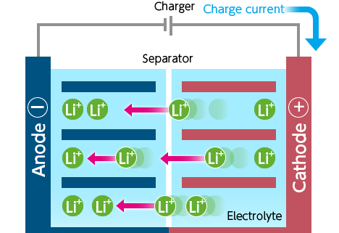

Cell stacking is crucial in the production of lithium-ion batteries, playing a key role in determining the voltage and capacity needed for various applications like electric vehicles and electronics.

Initially, each battery cell is created separately by constructing electrodes, separators, and electrolytes. These components are then combined to form a complete cell with cathodes, anodes, and electrolyte-soaked separators enclosed in metal casings. Proper alignment and orientation are essential to ensure correct electrical connections, usually arranged in alternating positive and negative terminal configurations.

The next step involves interconnecting the cells, either in series or parallel, to adjust the voltage and capacity of the battery pack. Connecting cells in series increases the voltage, while parallel connections increase the overall capacity. To ensure mechanical stability and electrical conductivity, the interconnected cells are bonded together, typically through welding.

After the cells are stacked, they may be assembled into larger modules, enclosed in protective casings, and equipped with thermal management components and safety features such as fuses and circuit protection. Rigorous testing is conducted to meet performance, safety, and quality standards, which include capacity, voltage, and impedance tests, as well as safety assessments like thermal cycling and short-circuit tests.

Finally, the battery modules are integrated into larger packs, complete with additional components like battery management systems (BMS), housing enclosures, and external connectors. This final assembly makes the battery packs ready for installation in various devices or systems. Efficient cell stacking plays a crucial role in ensuring optimal battery pack performance, safety, and reliability.

**Tab Welding:**

**Anode:**

For the anode (with Ni tabs), meticulous preparation precedes welding, involving cleaning to eliminate contaminants that might impede the welding process. Battery cells are then arranged appropriately, ensuring alignment of the tabs for precise welding, crucial for establishing reliable connections between cells. Subsequently, suitable welding methods such as resistance spot welding or laser welding are employed to fuse the Ni tabs, forming strong bonds essential for electrical connections on the anode side. Quality control measures, including visual inspection and electrical testing, verify the integrity of the welded joints, ensuring they meet specified standards for strength and conductivity. Finally, to safeguard against corrosion and ensure long-term reliability, the welded joints may undergo protection with insulating materials or coatings.

Nickel (Ni) is commonly used for anode tabs because it offers good electrical conductivity and corrosion resistance, which are essential for the anode's performance in lithium-ion batteries.

**Cathode:**

For the cathode (with Al tabs), a thorough preparation process involves cleaning the Al tabs to remove contaminants before welding. The battery cells are arranged in the desired configuration, ensuring precise alignment of the Al tabs for welding, crucial for establishing robust connections between cells. Welding methods such as resistance spot welding or laser welding are then employed to fuse the Al tabs, forming strong bonds essential for electrical connections on the cathode side. Quality control measures, including visual inspection and electrical testing, are conducted to verify the integrity of the welded joints, ensuring they meet specified standards for strength and conductivity. Finally, to prevent corrosion and ensure long-term reliability, the welded joints on the cathode side may be protected with insulating materials or coatings. These meticulous steps ensure the robustness and efficiency of the cathode connections, vital for the performance and longevity of lithium-ion batteries.

Aluminum (Al) is preferred for cathode tabs because it provides excellent conductivity and lightweight properties, making it suitable for the high-energy density and specific energy requirements of the cathode side.

**Pouch Cell Forming:**

Pouch cell forming is a critical step in the manufacturing process of pouch-type lithium-ion batteries. This process involves using materials like polymer laminate aluminum foil to create the pouch structure. Here's an overview of how pouch case forming works:

Material Selection

Pouch cells are usually made from a special type of material that is flexible, lightweight, and durable. This material is often a combination of polymer films and aluminum foil. These materials are chosen because they can prevent leaks of the battery's electrolyte and protect the internal components of the battery.

**Die Cutting**

The chosen polymer laminate aluminum foil material is cut into the right shape and size using special machinery with sharp blades. This precise cutting makes sure the pouch is the correct size and shape.

**Fold and Seal**

After cutting, the material is folded and sealed to make the pouch structure. Techniques like heat sealing or ultrasonic sealing are used to bond the edges of the material together securely. This creates an airtight seal and keeps the battery enclosure intact.

Electrode Insertion

Once the pouch case is formed, the electrode stack is inserted into the pouch. The electrode stack has layers of anode and cathode materials separated by electrolyte-soaked separator layers.

Tab Attachment

Electric tabs or leads are connected to the electrodes inside the pouch using processes like welding or soldering. These tabs create electrical connections and act as terminals for the battery.

**Electrolyte Injection and Sealing**

The pouch is filled with electrolyte through a small opening, which is then sealed to prevent leaks and maintain the battery's integrity. Techniques like heat sealing or adhesive sealing are used to ensure the pouch is securely closed.

**Final Inspection**

Before the pouch cell is used in battery packs, it undergoes a thorough inspection to check its quality and safety. This inspection includes visual checks, electrical testing, and leak testing to make sure the battery performs well and is safe to use.

Overall, the process of pouch case forming using polymer laminate aluminum foil as the material creates a flexible and lightweight housing for lithium-ion battery cells. This ensures the battery has the right barrier properties and is safe and reliable.

**Side Sealing :**

In the process of manufacturing lithium-ion batteries, the side sealing plays a crucial role in ensuring the safety and reliability of the final product. This report aims to provide a comprehensive overview of the side sealing process in lithium-ion battery manufacturing.

The side sealing process involves sealing the edges or sides of the pouch cell to create a secure enclosure for the internal components. Before sealing, the pouch cell is assembled with the electrode stack, electrolyte, and tabs, ensuring proper alignment in a fixture or jig. Various methods such as heat sealing and ultrasonic sealing are employed, where heat and pressure or high-frequency vibrations are applied to the pouch edges to melt and fuse the material together, creating strong, airtight seals. Quality control measures, including visual inspection, leak testing, and electrical testing, verify the integrity of the seals and ensure consistent quality. Any excess material is trimmed for a clean finish before the finished pouch cell undergoes further processing and integration into battery packs.

Efficient and reliable side sealing is essential for producing high-quality lithium-ion batteries with optimal safety, reliability, and performance. By understanding the importance of side sealing and implementing quality control measures, manufacturers can ensure that their lithium-ion batteries meet the necessary standards for performance and safety in various applications.

**Electrolyte Filling:**

The electrolyte filling process in lithium-ion battery manufacturing involves carefully injecting electrolyte into the pouch or cell enclosure to enable ion transport and facilitate electrochemical reactions within the battery. Prior to filling, the battery cell is prepared, typically with the electrode stack already assembled and the enclosure sealed except for a small opening designated for electrolyte injection. The electrolyte, a solution containing lithium salts dissolved in a solvent such as organic carbonates, is injected into the cell under controlled conditions to ensure precise volume and proper filling. Once filled, the opening is sealed to prevent leakage and maintain the integrity of the cell. Quality control measures, including monitoring electrolyte volume and composition, are employed to ensure consistency and adherence to specifications. Proper electrolyte filling is critical for achieving optimal battery performance, safety, and longevity, as it directly impacts ion conductivity and battery capacity.

**Final Sealing:**

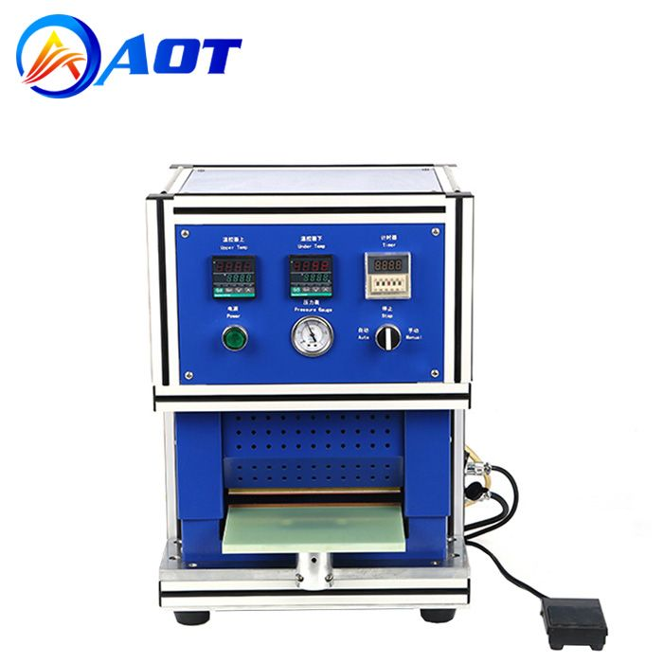

The final sealing of a pouch cell in lithium-ion battery manufacturing is a crucial step to ensure the integrity and safety of the battery enclosure. Once the pouch cell has been assembled, including electrode insertion, electrolyte filling, and possibly tab attachment, the final sealing process begins.

Typically, the remaining opening of the pouch is carefully sealed using a suitable method such as heat sealing or adhesive sealing. Heat sealing involves applying heat and pressure to the opening, causing the pouch material to melt and fuse together, creating a strong, airtight seal.

Adhesive sealing involves applying a specialized adhesive to the opening before pressing the edges together to form a secure bond. Both methods ensure that the electrolyte is contained within the pouch and prevent leakage during battery operation.

Quality control measures, such as visual inspection and leak testing, are often conducted to verify the integrity of the final seal and ensure that the battery meets safety and performance standards. Proper final sealing of the pouch cell is essential for maintaining the electrolyte integrity, preventing external contamination, and ensuring the long-term reliability of the lithium-ion battery.

**CONCLUSION:**

The manufacturing of cells for Electric Vehicles (EVs) in India is a big opportunity for growth and innovation in the car industry. Switching to electric vehicles is important to help the environment and reduce our use of fossil fuels. This report shows why it's crucial to invest in making cells for EVs to support the growing market in India.

Making improvements in cell technology can lead to better and more sustainable ways of getting around. By working on making cells charge faster and last longer, we can make EVs more appealing to people and help create a cleaner world.

Looking closely at how cells are made, like mixing, coating, stacking, and sealing, we see that each step needs to be done carefully to make top-quality lithium-ion batteries. By getting these processes right, we can keep up with the demand for EVs while meeting strict quality and safety rules. Starting cell manufacturing plants in India can boost the economy and encourage new technology and environmental friendliness.

In short, India has a chance to become a global leader in the electric vehicle movement by investing in making cells for EVs. This will not only help the country's economy but also lead to technological advances and a cleaner future for everyone.